**Deliverable 2: Project:**

**Create a simple React application Include setup steps, code snippets, and screenshots demonstrating the application in action.**

**Problem Statement-** BMI(Body Mass Index) Calculator.

Setup steps for React app-

1. Creating a react app

**npx create-react-app bmi**

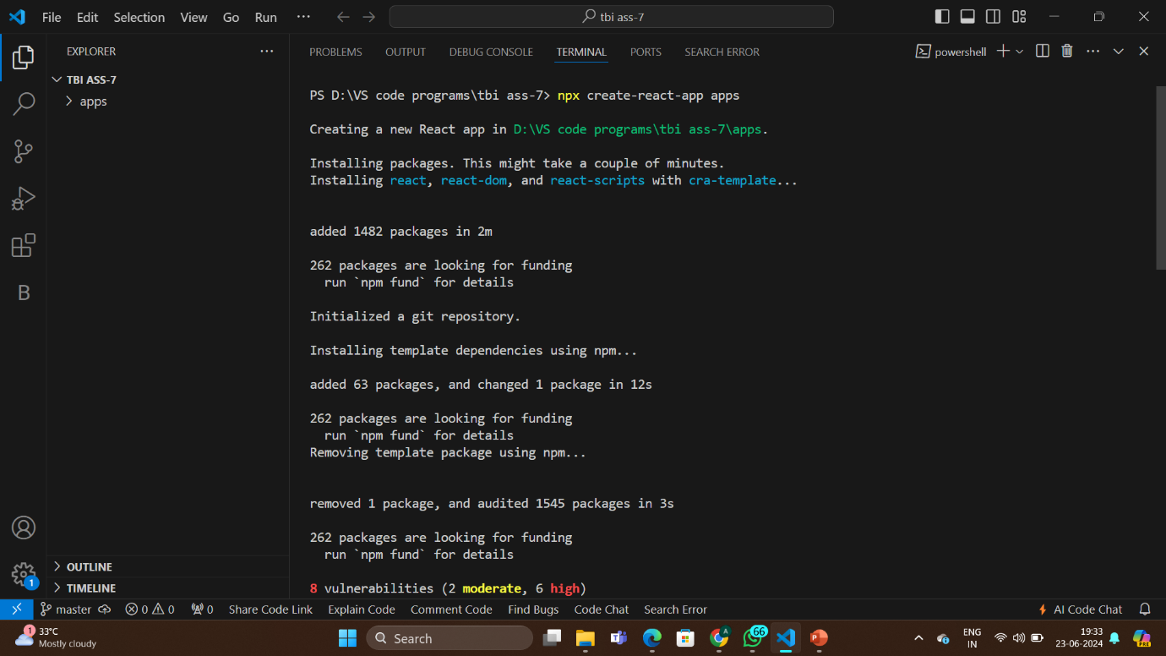

1. Navigate to my project folder

cd bmi

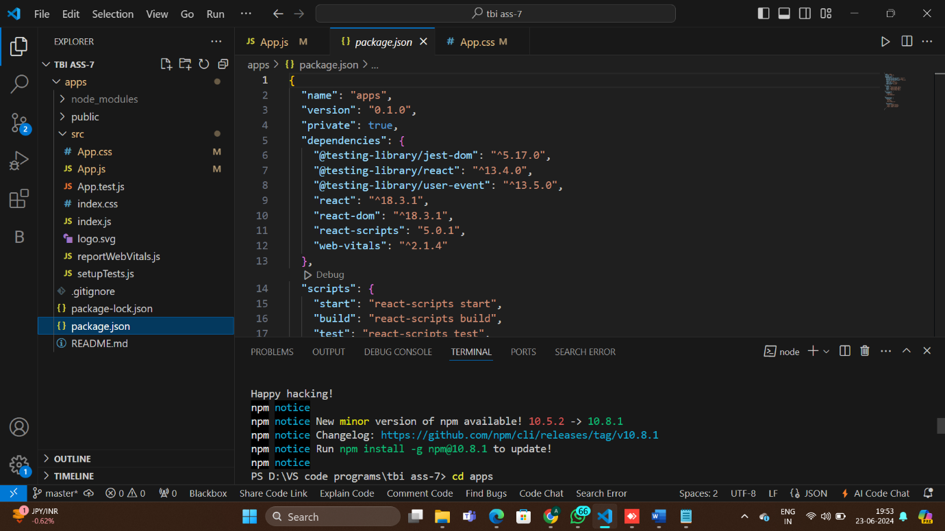

1. Writing code to file app.js

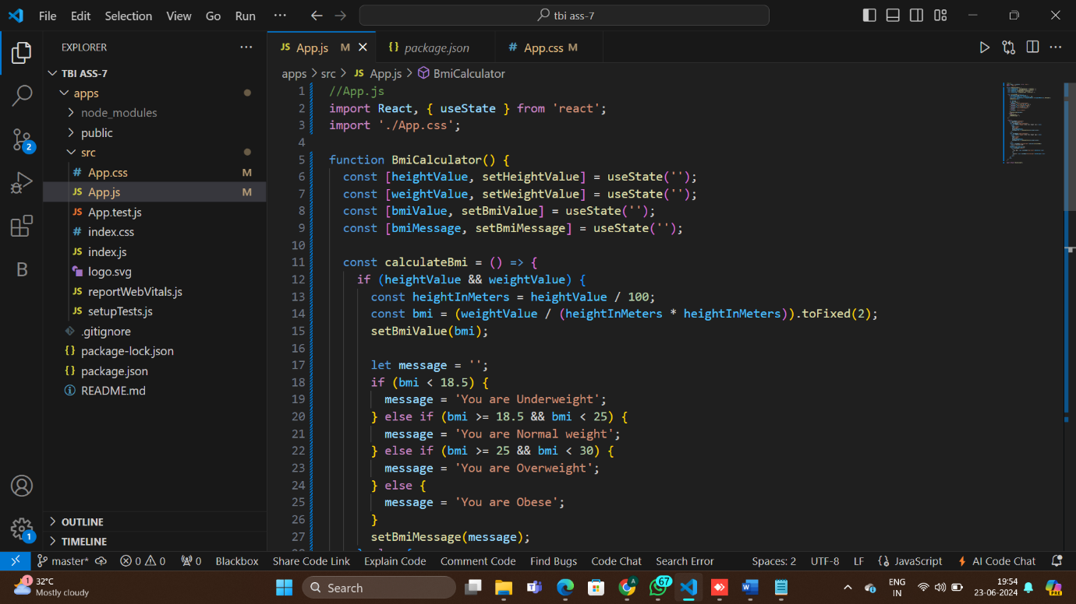

1. Writing code to file app.css

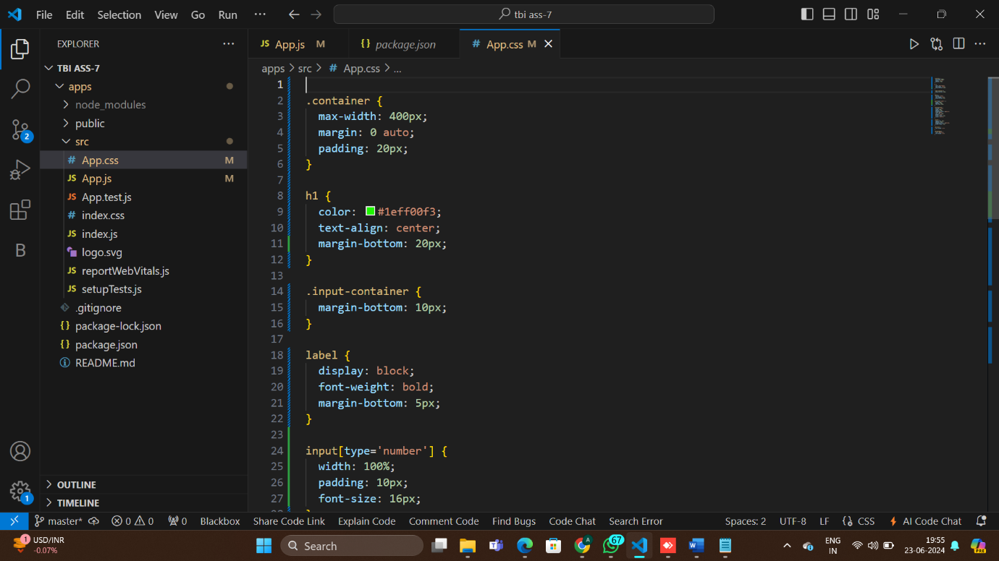

1. Saving code and Launching the app

npm start

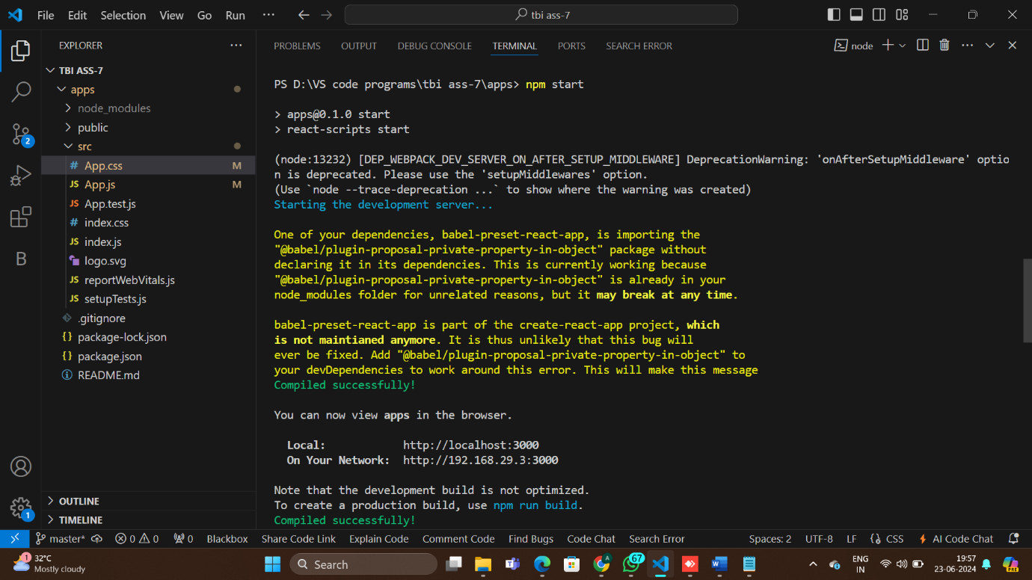

Result-

